Practical 8 — MySQL Database Design, ER Diagram, and Database
Connectivity

Aim
To design the StudentHub relational schema with an entity-relationship model and connect PHP to MySQL with safe defaults.

Theory
A relational design removes duplication by separating students, events and their many-to-many registrations, enforced with keys and referential actions.
- Tables: students with unique email, events with dated entries, and registrations linking the two with a uniqueness guard on the student-plus-event pair.
- Keys: primary keys per table, foreign keys from registrations to both parents with cascading updates and deletes.
- The design note matches the schema file exactly and includes both a diagram source and a plaintext version for print.
- Connectivity uses a central database file with a separate connectivity test page that reports success or failure without leaking credentials.
- Migrations for later practicals build on this base schema file.

Procedure
- Authored the base schema file under practical-8/database with students, events and registrations plus keys and constraints.
- Wrote the design note with diagram source and text fallback describing the one-to-many and many-to-many links.
- Added the central connection file and a connectivity test page.
- Inspected schema, note and connection files on disk; MySQL was not available on this machine so a live connection was not re-run here.

Screenshots
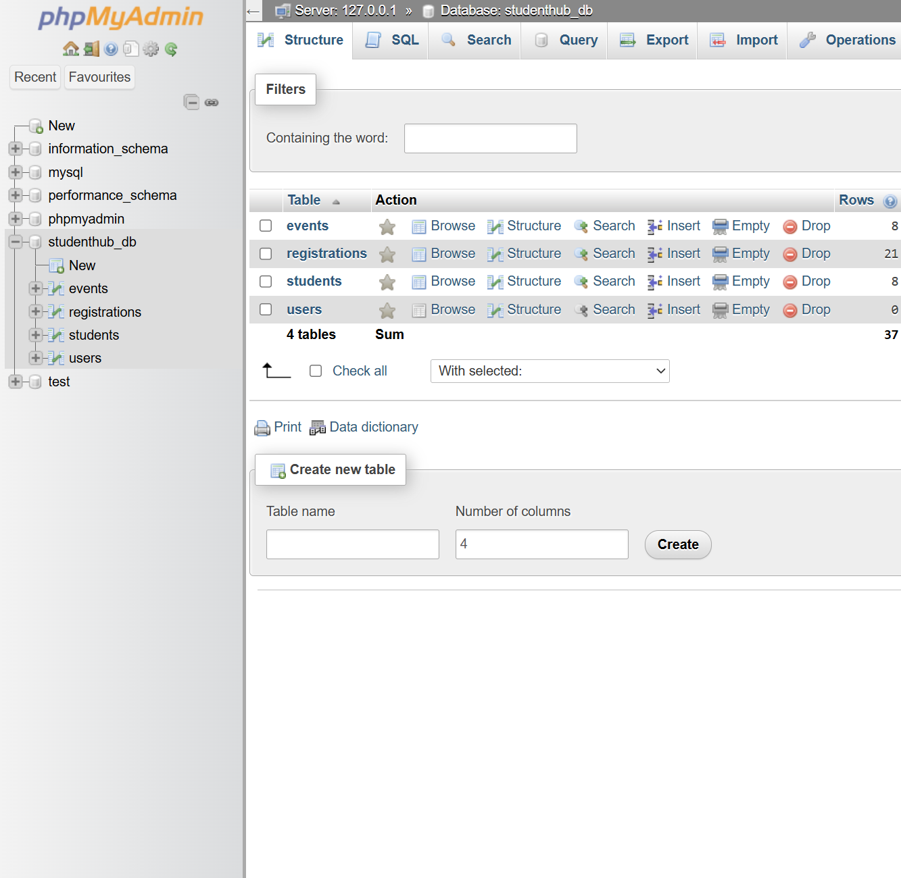
GitHub Repository Link
Practical repository : https://github.com/Rkpatel34/StudentHub/tree/main/studenthub

Conclusion
Practical 8 gave the project a sound relational footing with documented relationships and a single connection point for all later server work.

